**Answer for Facebook Forensics on different OS**

Q1. Screenshot of successfully setting up Linux VM in Virtual Box.

Q2. Screenshot of successfully installed Facebook application in Android VM in Virtual Box.

Q3. Screenshot of successfully setting up Win7 VM in Virtual Box.

Q4. Clear the cache, then after login into the account, search the keyword “_user=” in ChromeCacheView, then you can get 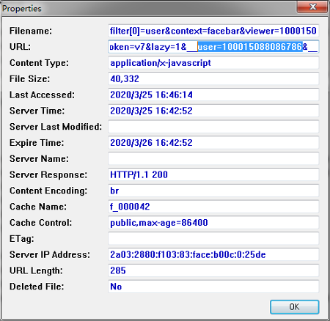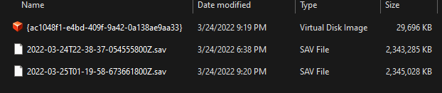the answer.

Q5. Screenshot of the virtual disk snapshot file and memory dump.

And you need to identify extension .vdi is the virtual disk snapshot file, and .sav is the memory dump. (In VMware, the memory dump extension would be .vmem)

Q6. You need to take screenshots of following four steps in Linux VM.

* 1. Login or main page of your Facebook page in Linux VM.
  2. Chat screenshot in Linux VM.
  3. Post and reply screenshot in Linux VM.
  4. Take the screenshot of your .vdi file and memory dump .sav file like Q5 answer.

Q7. Same screenshots as Q6, you just need to do all the steps on Win7 VM.

Q8. Same screenshots as Q5, you just need to do all the steps on Android VM.

Q9. Show the screenshot of your user 图像图像information findings after you put the hint keyword in your Linux .vdi file and memory dump .sav file.

To my experiment, I cannot find specific Facebook user information in .vdi file.

However, in memory dump, user information as following:

My user name and userID using keyword username

And login information:

My account email info using email keyword:

Q10. Show the screenshot of your user information findings after you put the hint keyword in图像图像图像 your Android .vdi file and memory dump .sav file.

**In .vdi file:**

You can find your main page URL when the keyword is your account name:

Also, you can find your UserID and other information when the keyword is your username:图像图像图像

When your keyword is your email, you can find your login information and your userID:

**In your Android memory dump file:**

When your keyword is your username:图像

Facebook Message app user key information:

Facebook app login information:图像

Login information with password, and the password is encrypted:图像

When your keyword is your login email:

Q11. Show the screenshot of your user information findings after you put the hint keyword in your Win7 .vdi file and memory dump .sav file.

**In your .vdi file:**

Login information which provided by html cache in .vdi. I didn’t fin图像图像d similar html cache in Linux and Android.

I didn’t find result when the keyword is Facebook login email.

**In your Win7 memory dump .sav file:**

**When the keyword is your login email, the memory dump directly shows the password!**

Q12. Show the screenshot of your chat information findings after you put the hint keyword in your Linux .vdi file and memory dump .sav file.

In Linux .vdi f图像图像图像ile, I cannot find chat information.

In Linux memory dump .sav:

A simple result as following, more screenshots will be shown in my research report document.

Q13. Show the screenshot of your chat information findings after you put the hint keyword in your Android .vdi file and memory dump .sav file.

I can only find friend accept alert and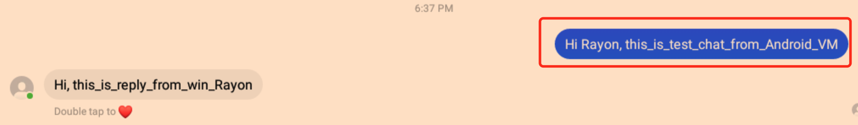图像图像 friend information in .vdi file, but nothing on chatting.

In Android memory dump .sav file:

This is a simple example; more screenshots will be shown in my research report document.

We can even find earlier chat before do the chat operation on Android VM:

Q14. Show the screenshot of your chat information findings after you put the hint keyword in 图像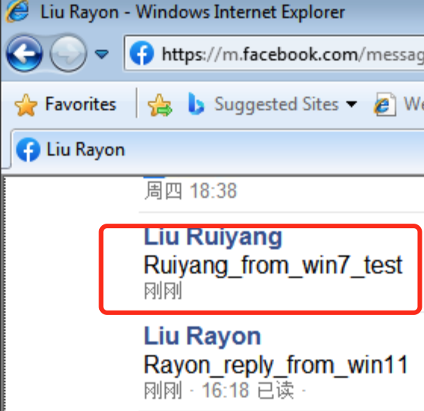图像your Win7 .vdi file and memory dump .sav file.

In Win7 .vdi file, I cannot find chat information.

In Win7 memory dump .sav file, which I didn’t get enough information.

Q15.

It is enough to have a reasonable idea of the results of the above questions because I believe that other people's experimental results may be different from mine.

The forensic results and detailed analysis for all Facebook operations can be found in my report slides and documentation, such as user information, login information, chat information, Post information, etc. The table is as following: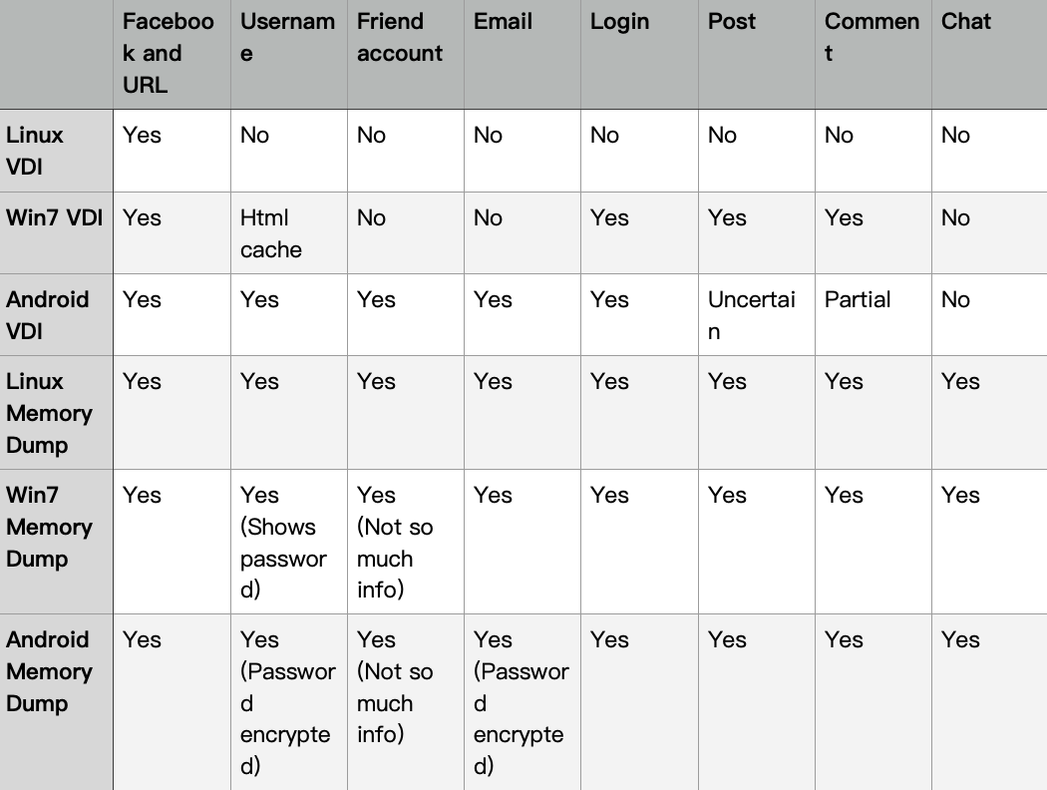

Although many of the search results in the memory dump are yes, they can provide different information and forms, which I will compare and elaborate on in detail in my research paper.